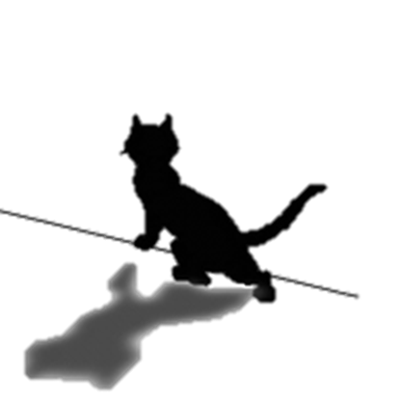MEMBERS WANTED
Rescue,
Rehabilitate & Re-home,
Stray & Abandoned Cats
Stray Cat
Rescue

Would you like to help Cats and Kittens on a regular basis?

Become a member of Stray Cat Rescue and pay a yearly/monthly subscription.

This will help our charity continue to be able to help stray, unwanted, feral and sick cats/kittens.

As a member you will receive our Newsletters which will give you information about what we have been doing and also future events. You will also receive an invitation to our Open Day which we hold every year in September where you can come and see some of the cats, give them a cuddle and help with raising some much needed funds towards the charity.

You can also visit our website www.straycatrescue.co.uk which will keep you updated regularly of all the work we are doing, some of the cats in our care and up and coming events.

Without people who donate to us regularly we could not exist and help the many cats and kittens that we do every year.

If you are interested in becoming a member please ring our Membership Secretary Sheri Jeffries on 01582 883765 or email her sherijeffries123@btinternet.com alternatively you can visit our website where you can print off a form and send in to the address on the form.

Stray Cat Rescue
P.O. Box 4217
Dunstable
LU6 1YQ
Tel:
01525 875993
01582 650167

Registered Charity No. 1098984

Chairman
Peter Devine
Stray Cat Rescue

P.O. Box 4217
Dunstable
LU6 1YQ
Tel:
01525 875993
01582 650167
Email:
straycatrescue@hotmail.com
www.straycatrescue.co.uk Registered Charity No. 1098984
Chairman
Peter Devine
Stray Cat Rescue

P.O. Box 4217
Dunstable
LU6 1YQ
Tel:
01525 875993
01582 650167
Email:
straycatrescue@hotmail.com
www.straycatrescue.co.uk Registered Charity No. 1098984
Chairman
Peter Devine
Stray Cat Rescue

P.O. Box 4217
Dunstable
LU6 1YQ
Tel:
01525 875993
01582 650167
Email:
straycatrescue@hotmail.com
www.straycatrescue.co.uk Registered Charity No. 1098984
Chairman
Peter Devine
Stray Cat Rescue

P.O. Box 4217
Dunstable
LU6 1YQ
Tel:
01525 875993
01582 650167
Email:
straycatrescue@hotmail.com
www.straycatrescue.co.uk Registered Charity No. 1098984
Chairman
Peter Devine
Stray Cat Rescue

P.O. Box 4217
Dunstable
LU6 1YQ
Tel:
01525 875993
01582 650167
Email:
straycatrescue@hotmail.com
www.straycatrescue.co.uk Registered Charity No. 1098984

